How to Write a Book: The Bucket Approach

Step One: Think of your book as one big bucket that contains 250 pages of content.

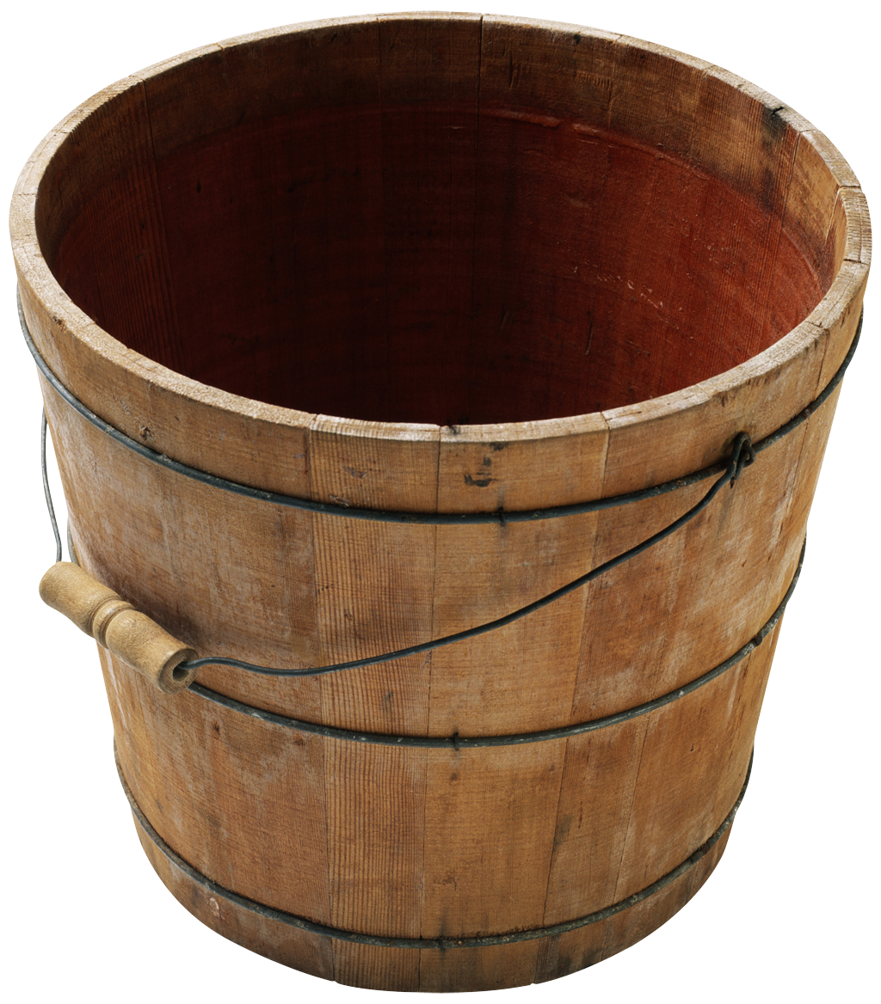

Step Two: Divide the content equally among 10 buckets (25-page chapters).

Step Three: Divide each chapter bucket into 5 smaller 5-page buckets (your main points or subheads.) Open the chapters with a story, preview the content of a particular chapter, and begin each subhead with a story.

Place two little bookend buckets before and after the big bucket: A ) a 5 page Introduction, telling the reader who you are, why you wrote the book, and what you hope they will gain from reading it (benefits & solutions) and B) a Conclusion that wraps it all up with a parting story offers your heartfelt best wishes to the reader.

You may deviate from this classic template, but only for extremely good reasons. Some authors prefer 20 12-page chapters. Some parcel their material into 50 5-page chapters. It all boils down to the same objective: 250 pages of excellent material.

